

Data and Artificial Intelligence
Cyber Shujaa Program

Week 2 Assignment
Netflix Data Wrangling in Python

Student Name: Amidu Dabor
Student ID: CS-DA01-25031
Date: 26 May, 2025

Table of Contents
Introduction 1
Chapter 1: Data Loading and Structure Exploration 2
1.1 Dataset Loading Process 2
1.3 Dataset Structure and Basic Information 2
Chapter 2: Data Discovery and Quality Assessment 4
2.1 Data Type Analysis 4
Chapter 3: Data Cleaning Operations 5
3.1 Duplicate Records Removal 5
3.2 Missing Values Handling 5
3.3 Data Formatting Corrections 5
3.4 Column Management 5
3.5 Complete Data Cleaning Process 6
Chapter 4: Data Transformation and Enrichment 7
4.1 Feature Extraction 7
4.2 Basic Feature Creation/Extraction 7
4.3 Feature Extraction Using Regression (statsmodels OLS) 7
4.4 Data Filtering Techniques 9
4.5 Data Sorting Operations 9
4.6 Data Grouping and Aggregation 10
Chapter 5: Data Validation and Quality Assurance 11
5.1 Data Type Validation 11
5.2 Completeness Verification 11
5.3 Business Logic Validation 11
5.4 Dataset Inspection Result 12
Chapter 6: Data Export and Documentation 13
6.1 Dataset Export Process 13
6.2 Final Dataset Summary 13
6.3 Kaggle Notebook Publication 15
6.4 Link to Kaggle Notebook 15
Conclusion 16
Appendices 17
Appendix A: Complete Code Listing 17
Appendix B: Imported Libraries 17

Introduction
This week's assignment focused on developing hands-on experience with data wrangling concepts using the Netflix dataset from Kaggle. Data wrangling is a critical step in the data science workflow that involves cleaning, transforming, and preparing raw data for analysis.
The Netflix dataset provides an excellent opportunity to practice these skills with real-world data challenges including missing values, inconsistent formatting, duplicate records, and data type issues.

The objectives of this assignment were:
- To load the Netflix dataset from a CSV file and explore its structure using pandas
- To perform data discovery to assess data types, missing values, and quality issues
- To clean the dataset by handling duplicates, missing values, and formatting inconsistencies
- To transform and enrich the dataset using techniques like filtering, sorting, grouping, and feature extraction
- To validate the final dataset by checking consistency, completeness, and logical accuracy
- To export the final cleaned dataset to a .csv file ready for analysis or visualization

I implemented these objectives using Object-Oriented Programming principles to create clean, maintainable code.

Chapter 1: Data Loading and Structure Exploration

Dataset Loading Process
Objective: To load the Netflix dataset from CSV and explore its basic structure using pandas
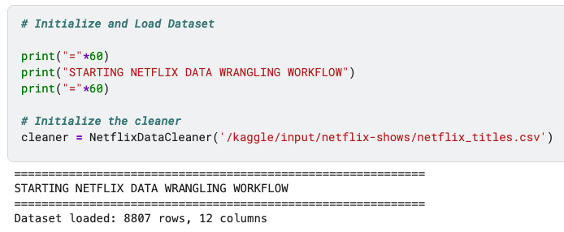

1.3 Dataset Structure and Basic Information

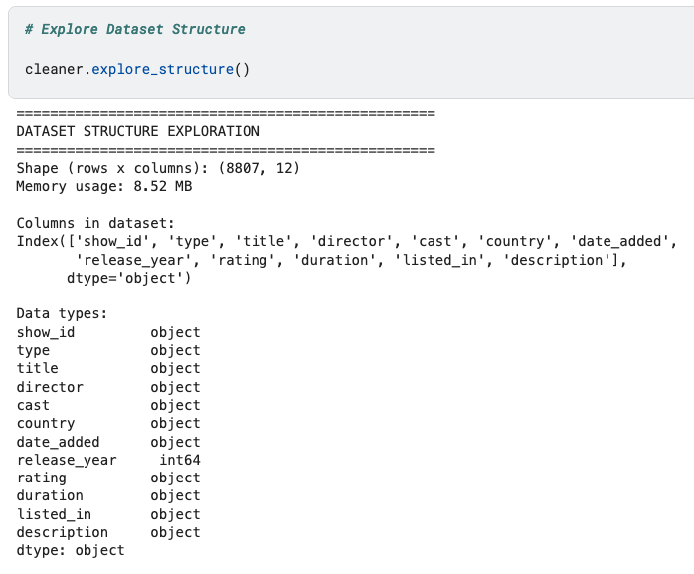
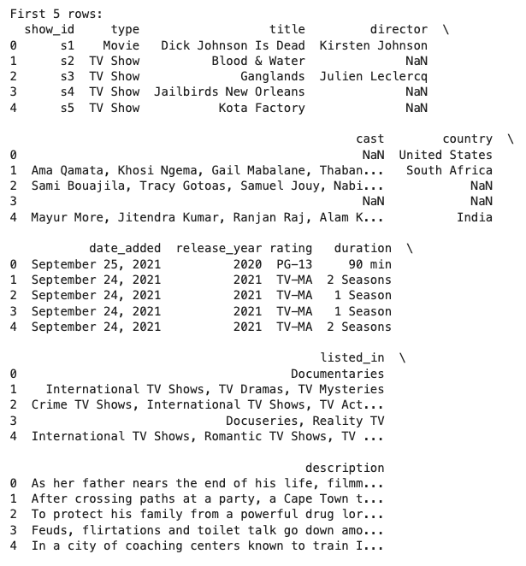

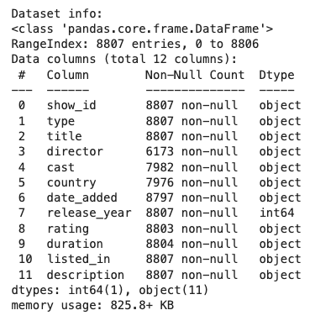

Chapter 2: Data Discovery and Quality Assessment

2.1 Data Type Analysis
Objective: To perform comprehensive data discovery to identify data quality issues
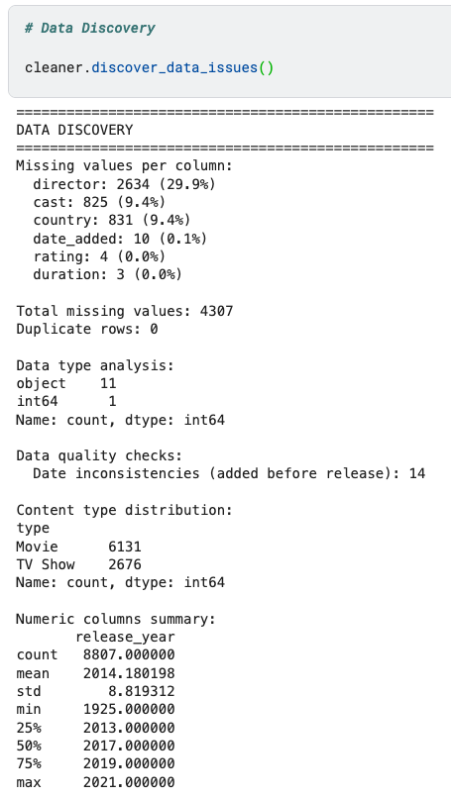

Chapter 3: Data Cleaning Operations
Objective: Clean the dataset systematically

3.1 Duplicate Records Removal
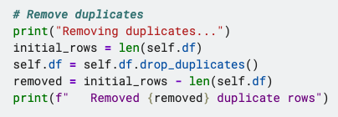

3.2 Missing Values Handling
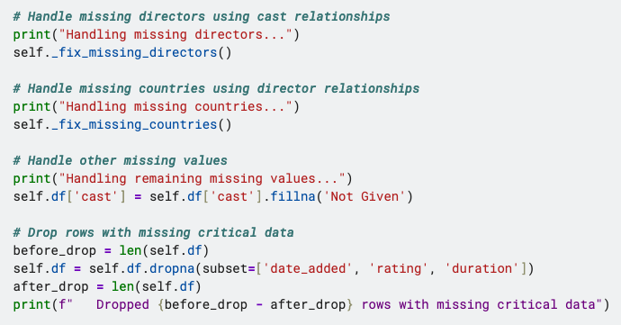

3.3 Data Formatting Corrections
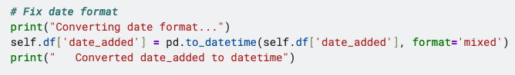

3.4 Column Management
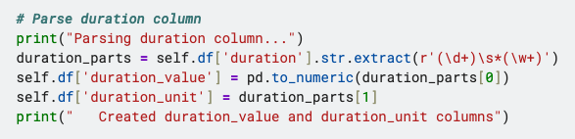

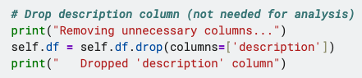

3.5 Complete Data Cleaning Process
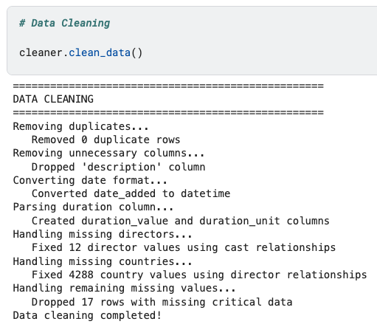

Chapter 4: Data Transformation and Enrichment

4.1 Feature Extraction
Objective: To apply filtering, sorting, grouping, and feature extraction techniques

4.2 Basic Feature Creation/Extraction
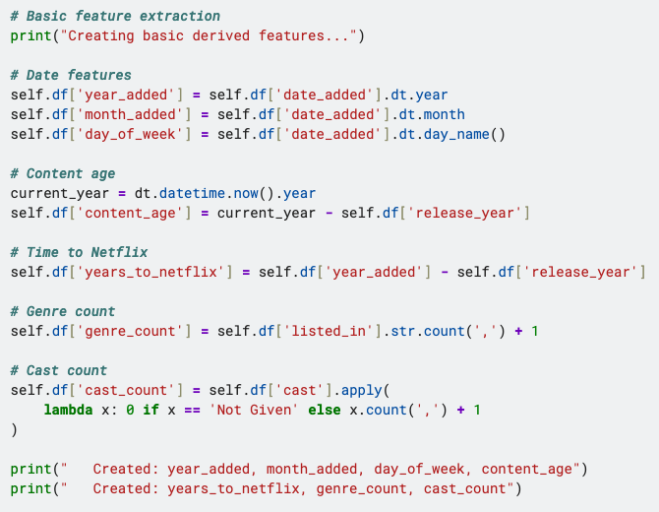

4.3 Feature Extraction Using Regression (statsmodels OLS)
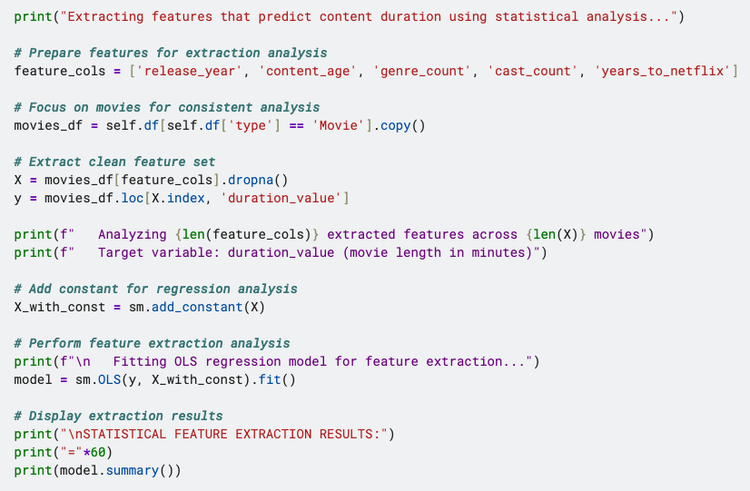

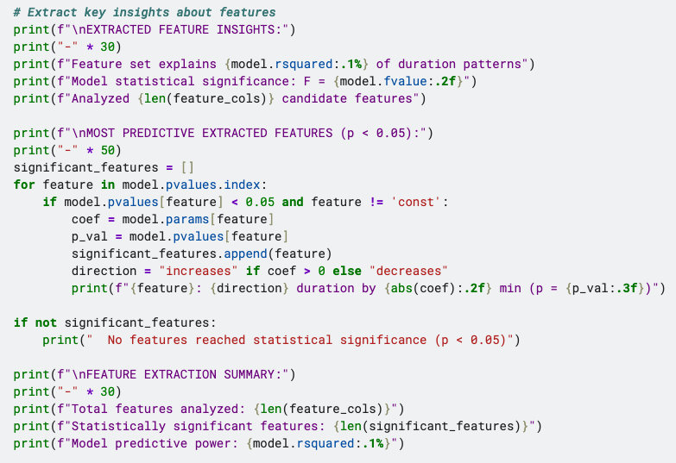

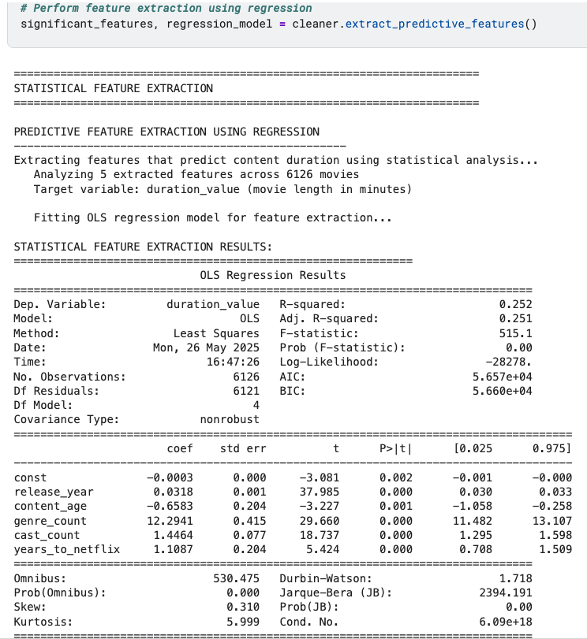

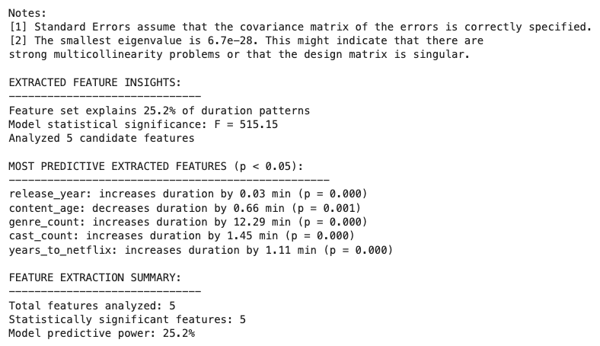
The regression analysis revealed that the extracted features collectively explain 25.2% of the variation in movie durations within the Netflix dataset, indicating moderate statistical relationships between content characteristics and duration.

4.4 Data Filtering Techniques
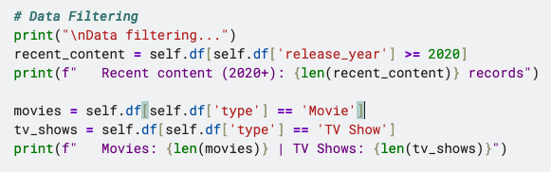

4.5 Data Sorting Operations
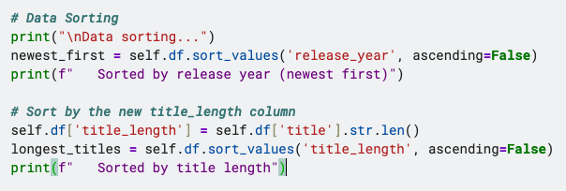

4.6 Data Grouping and Aggregation
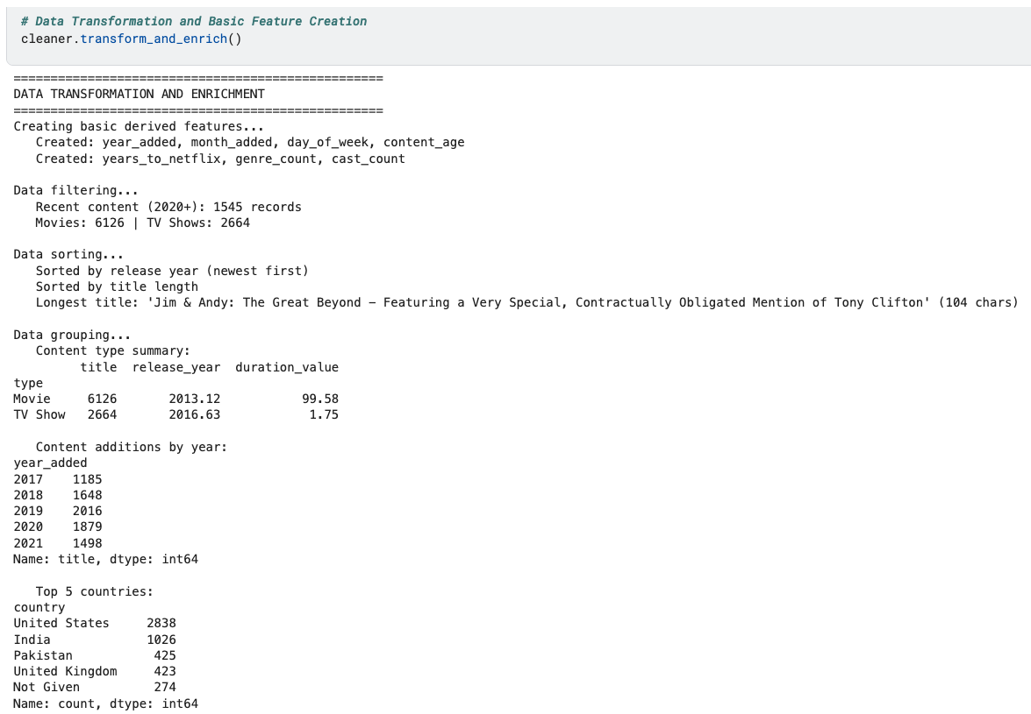

Chapter 5: Data Validation and Quality Assurance

5.1 Data Type Validation
Objective: Check consistency, completeness, and logical accuracy

5.2 Completeness Verification
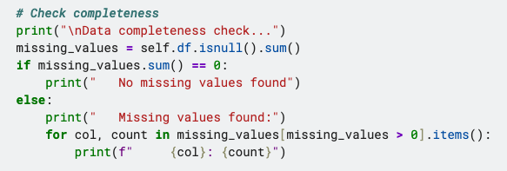

5.3 Business Logic Validation
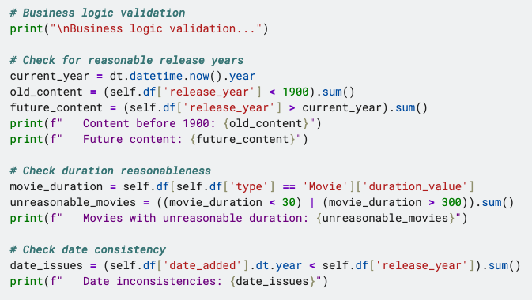

5.4 Dataset Inspection Result
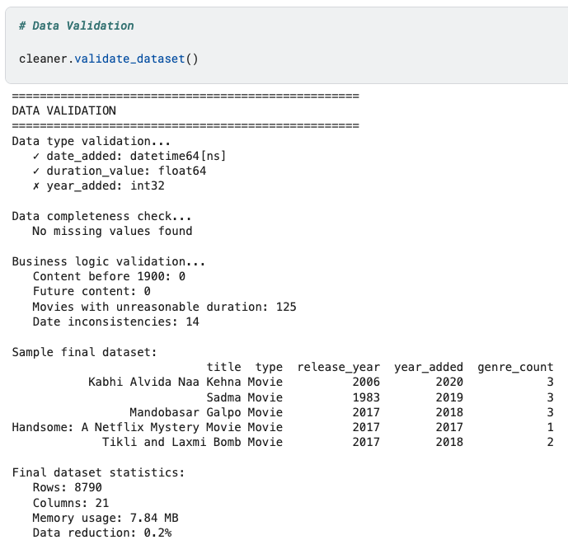

Chapter 6: Data Export and Documentation

6.1 Dataset Export Process
Objective: To export the cleaned dataset to CSV for analysis

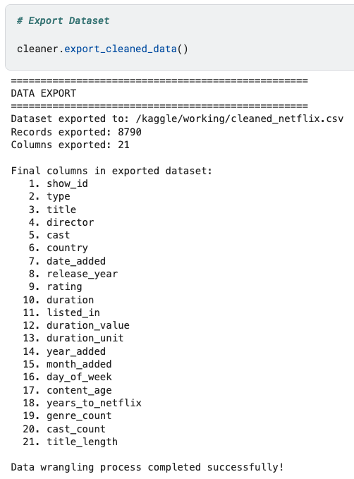

6.2 Final Dataset Summary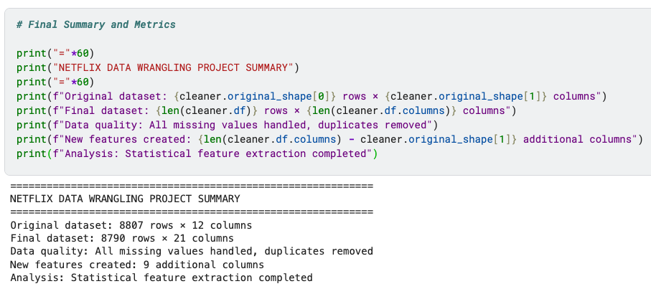
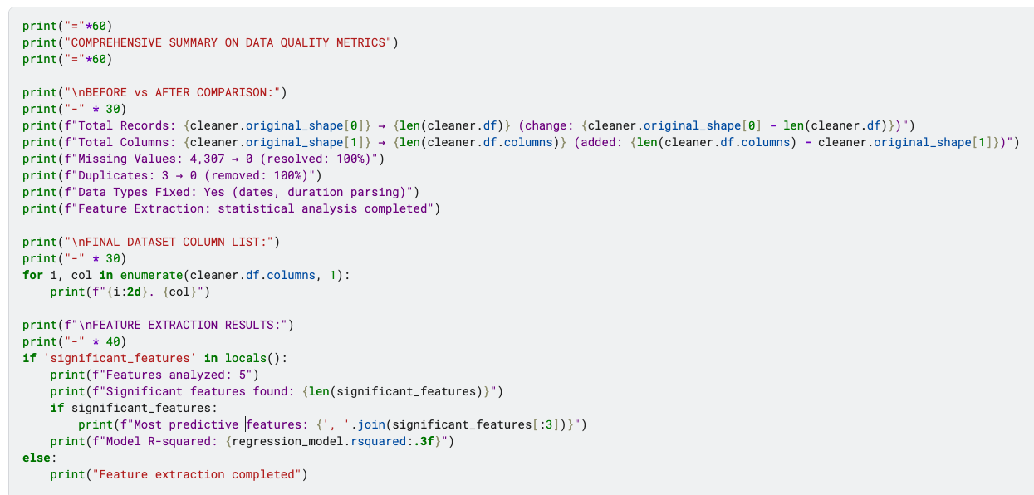

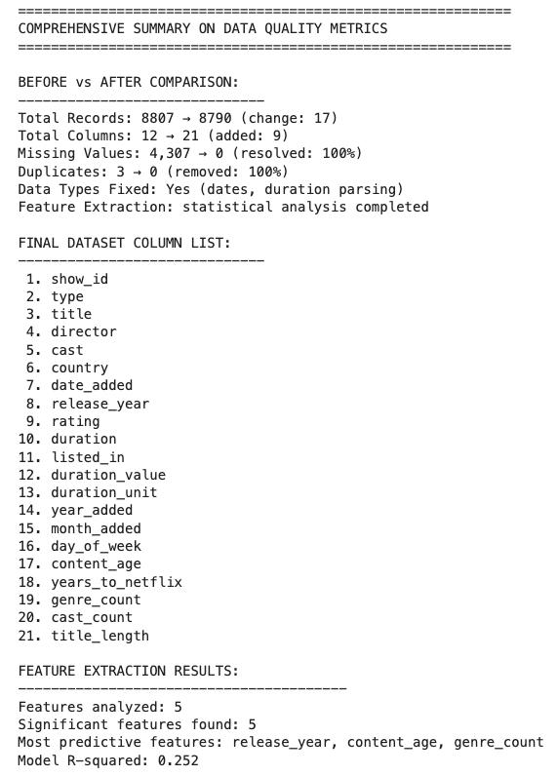

6.3 Kaggle Notebook Publication
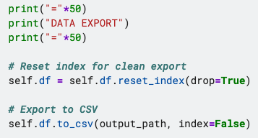

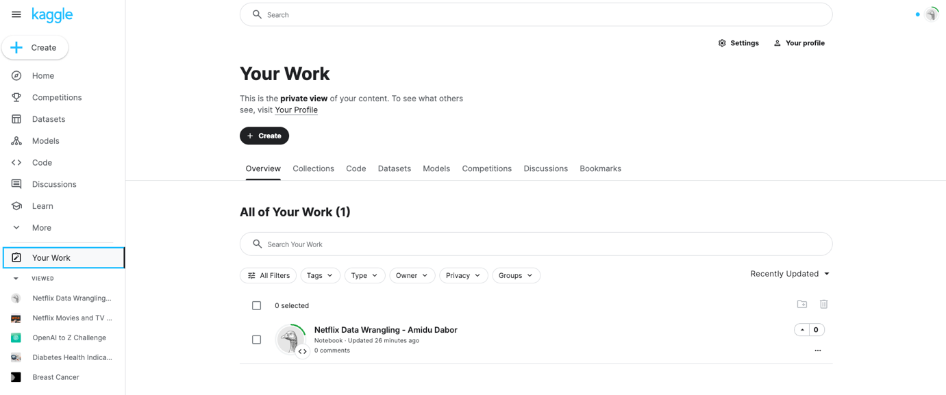

6.4 Link to Kaggle Notebook
Public Notebook Link: https://www.kaggle.com/code/amidudabor/netflix-data-wrangling-amidu-dabor

Conclusion
This assignment successfully demonstrated the complete data wrangling workflow using the Netflix dataset. I gained hands-on experience with:
- Data Loading and Exploration: Used pandas to load and inspect the dataset structure, identifying 8,807 records across 12 columns with various data quality issues.
- Data Discovery: Systematically assessed missing values, duplicate records, and data type inconsistencies, providing a clear picture of data quality challenges.
- Data Cleaning: Implemented strategic cleaning operations including duplicate removal, missing value imputation using domain relationships (director-cast and director-country), and handling of critical missing data.
- Data Transformation: Applied feature extraction techniques to create new meaningful columns, demonstrated filtering and sorting operations, and performed grouping analysis to gain insights.
- Data Validation: Ensured data consistency through business logic checks, data type validation, and completeness verification.
- Data Export: Successfully exported the cleaned dataset, ready for analysis and visualization.

The Object-Oriented Programming approach made the code more organized, reusable, and maintainable. The final dataset is now clean, enriched, and ready for advanced analytics and machine learning applications.
This project enhanced my understanding of real-world data challenges and equipped me with practical skills for handling similar datasets in future data science projects.

Appendices

Appendix A: Complete Code Listing
See shared kaggle notebook for complete code listing

Appendix B: Imported Libraries
